

# CRITICS’ PICKS

# TORONTO

# Steven Beckly

## DANIEL FARIA GALLERY 188 St Helens Avenue January 18 - February 24

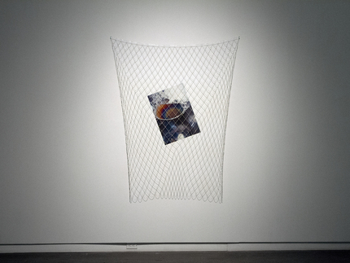

Steven Beckly, *Pool of Andromeda*, 2017–18, vinyl photograph and silver chain, dimensions variable.

Twenty years ago, after the dissolution of a romantic relationship, American artist [Roni Horn](https://www.artforum.com/search?search=Roni%20Horn) began traveling to London to photograph the River Thames. She created restrained images dense with surface incident and which suggest complex depths. The young Canadian artist [Steven Beckly](https://www.artforum.com/search?search=Steven%20Beckly) is also drawn to water, but the unframed photographs in this exhibition convey buoyancy and transformation. The dark beauty of Horn's watery images contrasts with Beckly's light touch.

The show's title, “Meirenyu,” is a transliteration of the Mandarin word for “mermaid.” The mythical creature's hybridity provides a framework for understanding Beckly's works' form and content: photographs become sculptures, and bodies become bodies of water. *Mood Ring*, 2017, is an abstract color field whose tones range from sand to sky. Its center has been scorched, and a long pin pierces the warped transparency to fasten the work to the wall. (The pin is festooned with small pearls, themselves the product of an undersea transformation.) Other images are presented on foil, pearlized paper, or vinyl. *Soft Tissue*, 2017, is a photograph of a male torso printed on tissue; the material's folds and creases artificially age the lithe young body.

Beckly is opportunistic, finding beauty in such subjects as the soap-dish bubbles of *Pool of Andromeda*, 2017-18. As the ravishing Greek figure was lashed to a rock, so too is this photograph trapped behind delicate silver chains. Elsewhere, four curled figures, *Blue Dancers*, 2017-18, hang from the gallery's ceiling. Their sun-dappled waves look like so many galaxies, an impression echoed in *Untitled (0)*, 2017, which summons stars from the pool of water nestling in a rocky surface. Beckly's commitment to beauty, fluidity, and hybridity gives this exhibition heft without weighing it down.

*—*[*Brian Sholis*](https://www.artforum.com/contributor/brian-sholis)

-Sholis, Brian. “Critics’ Picks,” *Artforum*, February 8, 2018. <<https://www.artforum.com/picks/steven-beckly-74149>>.